**Scom**  **Antenna**

**Installation Manual for Scom Gama Fed Dipole Antenna**

**Model DP 2F**

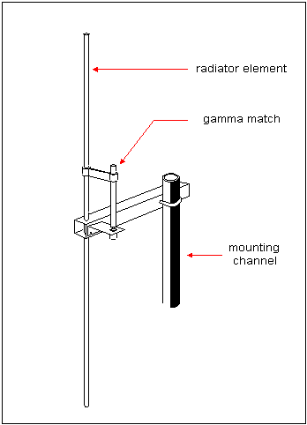

Insert the aluminum tube through the large hole and align the hole at its middle part to

the 1/8" diameter hole at the side of the channel (see Figure 6.7).



**Figure 6.7** Inserting the aluminum tube into the mounting channel.

**Figure 6.8** Locking the tube with a self tapping screw

Insert a self tapping screw through the sidehole and forcibly screw it into the

smaller hole of the tube inside (see Figure 6.8). Tighten the screw until the

aluminum tube is rigidly held in the aluminum channel.

.

Attach the bracket into the mounting channel by screwing it with small self

tapping screws (see Figure 6.9).



**Figure 6.9** Fixing the feedpoint bracket on the mounting channel.

Stop the gamma tube just about 1/2 inch above plane of the angle bracket or just enough

for the gamma tube to cover the whole PE insulator. Insert a bolt into the tuning clamp

attached around the radiator element and tighten it lightly enough to hold the gamma

matching assembly in place. The antenna is already mechanically ready at this point, it

only needs to be tuned to resonance for proper operation.



**Figure 6.10** Assembling the gamma tube into the gamma match.

**Figure 6.11** Raising or lowering the tuning clamp to find the best match

To tune the antenna: Attaché Coax cable to connector fixed under gama fed. move the tuning clamp and find the position where you can get the

lowest SWR response for the center frequency and a relatively flat response curve over

the entire band. Move the tuning clamp either lower or higher about 1/4 inch at a time

(see Figure 6.11).

|  |
| --- |
|  |

. Contact:

**2 Koldongri, 9A Tailor Compound,**

**Sahar Rd. Near Garware, Andheri (E)**

**Mumbai 400069, Maharashtra**

**Tel/Fax: 022-26845875, +91 9819469249**

**Email: scomantenna@gmail.com**